**OOAD PROJECT**

**CRICKET FANTASY LEAGUE**

**Group Members:**

Ali Asim (61906)

Shazad Shiraz (62462)

Qasim Naqvi (62722)

Table of Contents

USE CASE 4

ACTORS & MAIN USE CASES: 5

❖ ADMIN 5

❖ PARTICIPANTS 5

❖ GUEST 5

FLOW OF EVENTS 6

Login 6

❖ Preconditions 6

❖ Main Flow 6

❖ Alternative Flow 6

League Management 7

❖ Preconditions 7

❖ Main Flow 7

❖ Sub Flow 7

❖ Alternative Flow 7

Manage Players 8

❖ Preconditions 8

❖ Main Flow 8

❖ Sub Flow 8

Manage Matches 9

❖ Preconditions 9

❖ Main Flow 9

Make Announcements 9

❖ Preconditions 9

❖ Main Flow 9

Add Points 10

❖ Preconditions 10

❖ Main Flow 10

Invite Participants 10

❖ Preconditions 10

❖ Main Flow 10

Enter League 11

❖ Preconditions 11

❖ Main Flow 11

❖ Sub Flows 11

Search Leagues 12

❖ Preconditions 12

❖ Main Flow 12

View Announcements 12

❖ Preconditions 12

❖ Main Flow 12

See Leagues 13

❖ Precondition 13

❖ Main Flow 13

# USE CASE

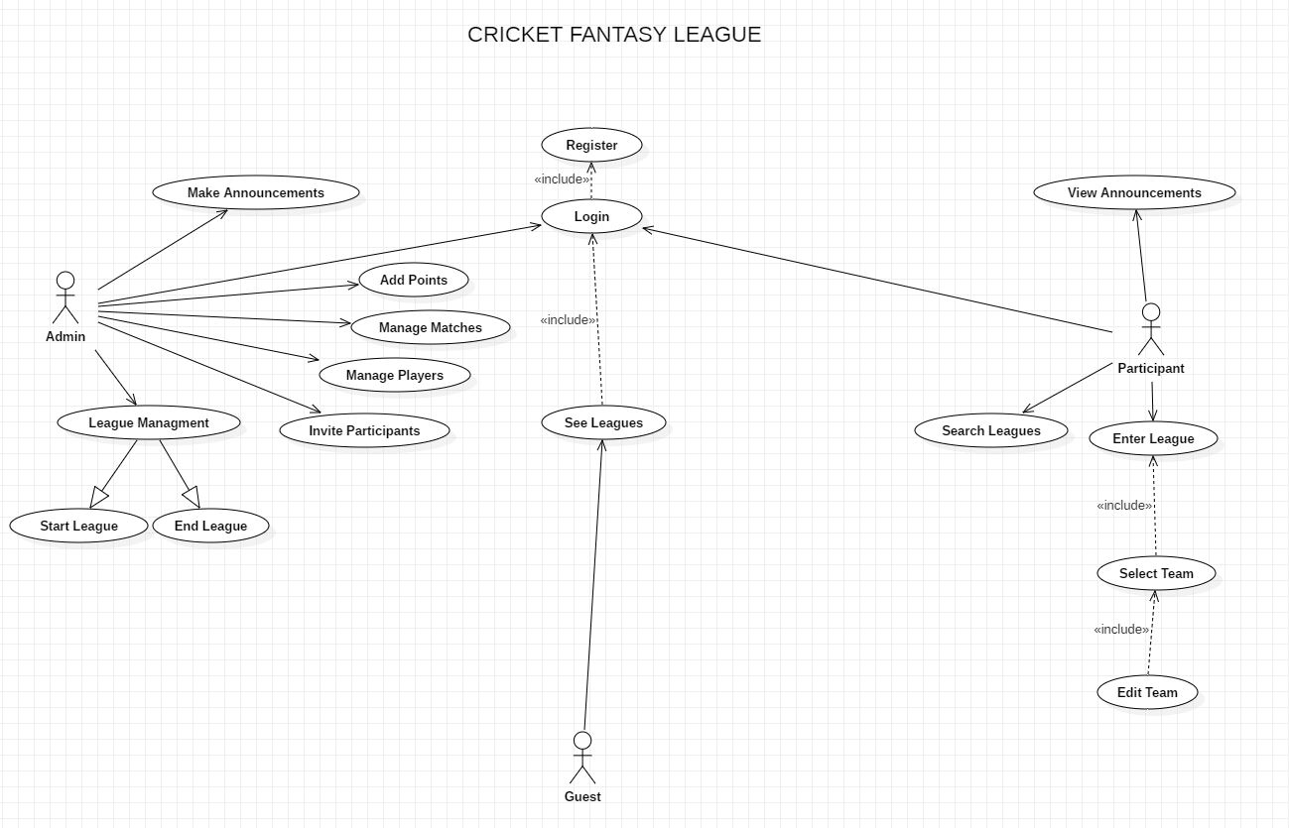

# ACTORS & MAIN USE CASES:

* + Login.

### ADMIN

* + Start League
  + End League
  + Manage Players
  + Add Points
  + Make Announcements
  + Invite Participants

### PARTICIPANTS

* + View Announcements
  + Search Leagues
  + Enter League

### GUEST

* + See Leagues

# FLOW OF EVENTS

## Login

### Preconditions

Before this use case begins there will be a necessary check that the user is registered in our database or not, after which the user will be identified as Admin or Participants and will be entertained accordingly.

### Main Flow

Whenever a user tries to perform any tasks this use case will check that if the user is already logged in or not. The app will require an Email and password. If he/she is already logged in then he will be continued with his/her activity. Otherwise an alternative flow will be performed.

### Alternative Flow

Entered Email is not available then generates an alert and redirect user to update password or exit the app.

## League Management

### Preconditions

Before this use case begins one or more following use cases should be executes

* Start League
* End League

### Main Flow

If the admin choose to start a new league. The admin will be directed to a new page which actually has a form to fill. This will include INSERT LEAGUE NAME. After this field is filled then app will check for the availability of the inserted League Name which is a sub flow.

If the admin choose to end the league. The admin will be directed to a new page where admin will be required to enter his/her password then proceed to End League but if the League has more than 10 participants an alternative flow will be executed.

### Sub Flow

#### Insert League Name:

App will now check the availability of the League Name. If the admin’s desired League Name is available then the Admin can enter data into other fields, otherwise Admin will be asked to enter a different name.

### Alternative Flow

Alternative Flow will ask the admin to choose another league to end or terminate the use case.

## Manage Players

### Preconditions

Before this use case begins the app will check that the league name which admin has entered is created by him/her.

### Main Flow

When the admin enters this use case, he/she will be provided by two options. This includes ADD PLAYERS and EDIT PLAYERS.

There will be no option to remove a player because when leagues start players are only changed and they are used according to the matches.

If the activity selected is ADD PLAYERS, then add player sub flow will start, If the activity selected is EDIT PLAYERS, then edit player sub flow will start.

### Sub Flow

#### ADD PLAYER

Admin can add player name, player team, playing style and category in this sub flow.

#### EDIT PLAYER

Admin can edit the player information through this sub flow.

## Manage Matches

### Preconditions

Before this use case begins the app will check that the league name which admin has entered is created by him/her.

### Main Flow

When Admin gets in this use case the he/she will be provided with the page where he/she can enter all the matches, and future matches which are not been announced yet can also be added in future.

## Make Announcements

### Preconditions

Before this use case begins the Admin must have 10 or more participants in the league in which he/she is going to make an announcement.

### Main Flow

This use case begins when Admin selects the Make Announcements button from its dashboard. Then app will allow them to write a text and then send to all participants.

## Add Points

### Preconditions

Before this use case begins the app will check that the league name which admin has entered is created by him/her.

### Main Flow

When this use case will start, the admin will be asked to enter points for specific actions. For example, “Enter Points for 6”, “Enter Points for 4”, “Enter points for MOTM”, etc. These points will then be used to calculate the participant performances.

These points can only be entered once.

## Invite Participants

### Preconditions

Admin can only Invite Participants until he/she has at least 3 **past** leagues to their name.

### Main Flow

The admin selects Invite Participants option and begins this use case. This use allows admin to invite participants to their league and play.

## Enter League

### Preconditions

Participant must have entered in less than 3 leagues.

### Main Flow

Participant can begin this use case when they try to enter a league. They will be provided options to SELECT TEAM and EDIT TEAM are sub flows of this use case.

### Sub Flows

#### SELECT TEAM

Participant needs to select a team initially to enter the league.

#### EDIT TEAM

Participant needs to edit a team time to time according to matches.

## Search Leagues

### Preconditions

None

### Main Flow

This use case begins when Participant search for a league to enter. A search page will be provided to search the league and then the database will be searched as if there is any league of the particular name if yes, Participant will be shown its welcome page. If not then participant will be shown an error.

## View Announcements

## Preconditions

Participants must be in a league to view announcements.

## Main Flow

Participant can begin this use case by selecting the view announcement option and view the announcements made by Admin of the league.

## See Leagues

### Precondition

None

## Main Flow

This user case will begin when user is not registered or logged in so he/she can only view leagues and cannot perform any activity